Noah’s Ark
Pray together

Begin-
What do you know about Noah’s Ark? Write the answers on a board.

Activity
What would you bring onto the Ark? Everyone will decide on 5 things they would bring. Then as a group will come together and vote on only 15 things. (The numbers can vary depending on the number of youth)

Story- Beginning (Genesis 6:9-22)
Measure the length and width of the ark in a parking lot (if you can). The ark was about 450 feet long, 75 feet wide, and 45 feet tall. (Genesis 6:15- numbers vary depending on the cubic used) Storage of 450 semi-trailers. (Information is taken from the ark encounter in KY.)

Questions-
Why did God want to flood the earth? (Genesis 6:5-13) Violent people with no faith in God
How many people on the Ark? (Genesis 7:13) 8 people who believed in God

Story – Flood (Genesis 7:1-8:12)
Who closed the door? (Genesis 7:16) God. Noah and his family had no option to try to save others.
How many days? 377 days. This is dependent on a calendar where all months are 30 days. See how patient by counting days on a calendar.

Story – Land (Genesis 8:13-9:17)
What did Noah do to check if the water went down? (Genesis 8:6-12) Sent out the birds to find land
What does a rainbow mean? (Genesis 9:15) Water will never again flood to destroy all life.
What saved Noah and his family? (1 Peter 3:20) Water- because it saved them from mean people who didn’t believe in God.

How many people on the Ark?
Find the different number

9999999999999999999999999999999999999999999999
9999999999999999999999999999999999999999999999
9999999999999999999999999999999999999999999999
9999999999999999999999999999999999999999999999
9999999999999999999999999999999999999999999999
9999999999999999999999999999999999999999999999
9999999999999999999999999999999999999999999999
9999999999999999999999999999999999999999999999
9999999999999999999999999999999999999999999999
9999999999999999999999999999999999999999999999
9999999999999999999999999999999999999999999999
9999999999999999999999999999999999999999999999
9999999999999999999999999999999999999999999999
9999999999999999999999999999999999999999999999
9999999999999999999999999999999999999899999999
9999999999999999999999999999999999999999999999
9999999999999999999999999999999999999999999999
9999999999999999999999999999999999999999999999
9999999999999999999999999999999999999999999999
9999999999999999999999999999999999999999999999
9999999999999999999999999999999999999999999999
9999999999999999999999999999999999999999999999
9999999999999999999999999999999999999999999999

How many days on the Ark?
Days Between
Event
0

40

110

73

40

7

7

23

14

56

Flood Starts

Rain stops

Ark Floats

See Mountains

Raven Sent

Dove Sent

Dove leaves

Flood over

Noah opens Door

Noah leaves Ark

How many days?
How patient are you?

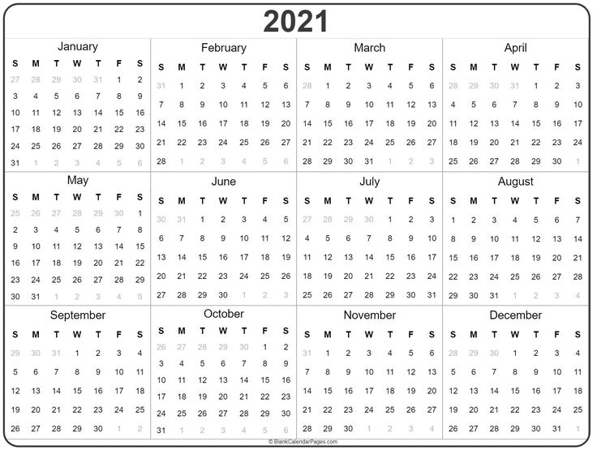

What does a rainbow mean?

 | 1 | 2 | 3 | 4 | 5 | 6 | 7
1 | A | B | C | D | E | F | G
2 | H | I | J | K | L | M | N
3 | O | P | Q | R | S | T | U
4 | V | W | X | Y | Z

2nd number
1st number

_____ ____ _____
24 11 63 51 43 24 22 52 52 72 51 14 51 43
_____ _____ __
11 71 11 22 72 61 52 13 13 41 63 13
_______ ___ ____.
41 51 53 63 43 13 44 11 52 52 52 22 61 51

How many people on the Ark?
Find the different number

9999999999999999999999999999999999999999999999
9999999999999999999999999999999999999999999999
9999999999999999999999999999999999999999999999
9999999999999999999999999999999999999999999999
9999999999999999999999999999999999999999999999
9999999999999999999999999999999999999999999999
9999999999999999999999999999999999999999999999
9999999999999999999999999999999999999999999999
9999999999999999999999999999999999999999999999
9999999999999999999999999999999999999999999999
9999999999999999999999999999999999999999999999
9999999999999999999999999999999999999999999999
9999999999999999999999999999999999999999999999
9999999999999999999999999999999999999999999999
9999999999999999999999999999999999999899999999
9999999999999999999999999999999999999999999999
9999999999999999999999999999999999999999999999
9999999999999999999999999999999999999999999999
9999999999999999999999999999999999999999999999
9999999999999999999999999999999999999999999999
9999999999999999999999999999999999999999999999
9999999999999999999999999999999999999999999999
9999999999999999999999999999999999999999999999

What does a rainbow mean?

 | 1 | 2 | 3 | 4 | 5 | 6 | 7
1 | A | B | C | D | E | F | G
2 | H | I | J | K | L | M | N
3 | O | P | Q | R | S | T | U
4 | V | W | X | Y | Z

Water will never
_____ ____ _____
24 11 63 51 43 24 22 52 52 72 51 14 51 43
again flood to
_____ _____ __
11 71 11 22 72 61 52 13 13 41 63 13
destroy all life
_______ ___ ____.
41 51 53 63 43 13 44 11 52 52 52 22 61 51

