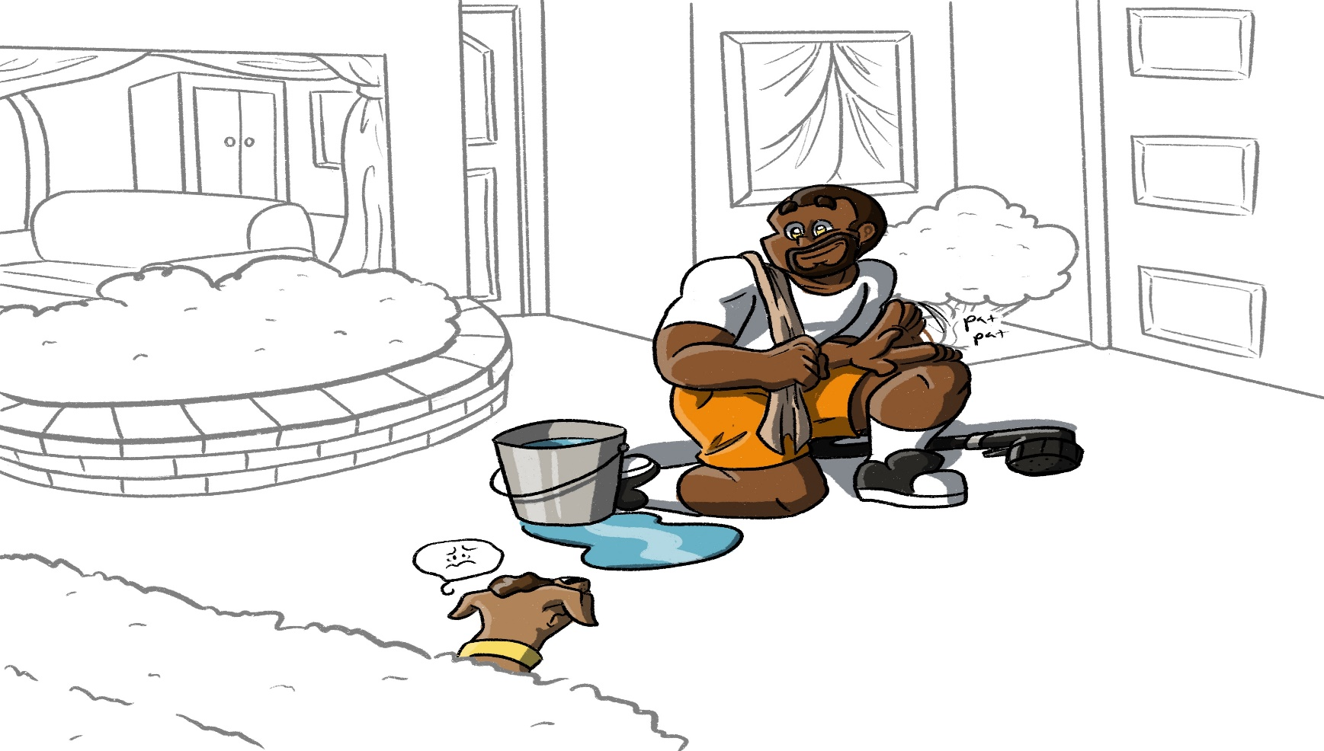
If God Loves Everyone, Why Don’t All People Go to Heaven?

What My Dog Taught Me.
Written by Denise Pulfer
Illustrated by Joshua Manning

This book is dedicated to Deaf Youth Ministry of Texas.
True story of Pixie (my dog) and Me.
2020

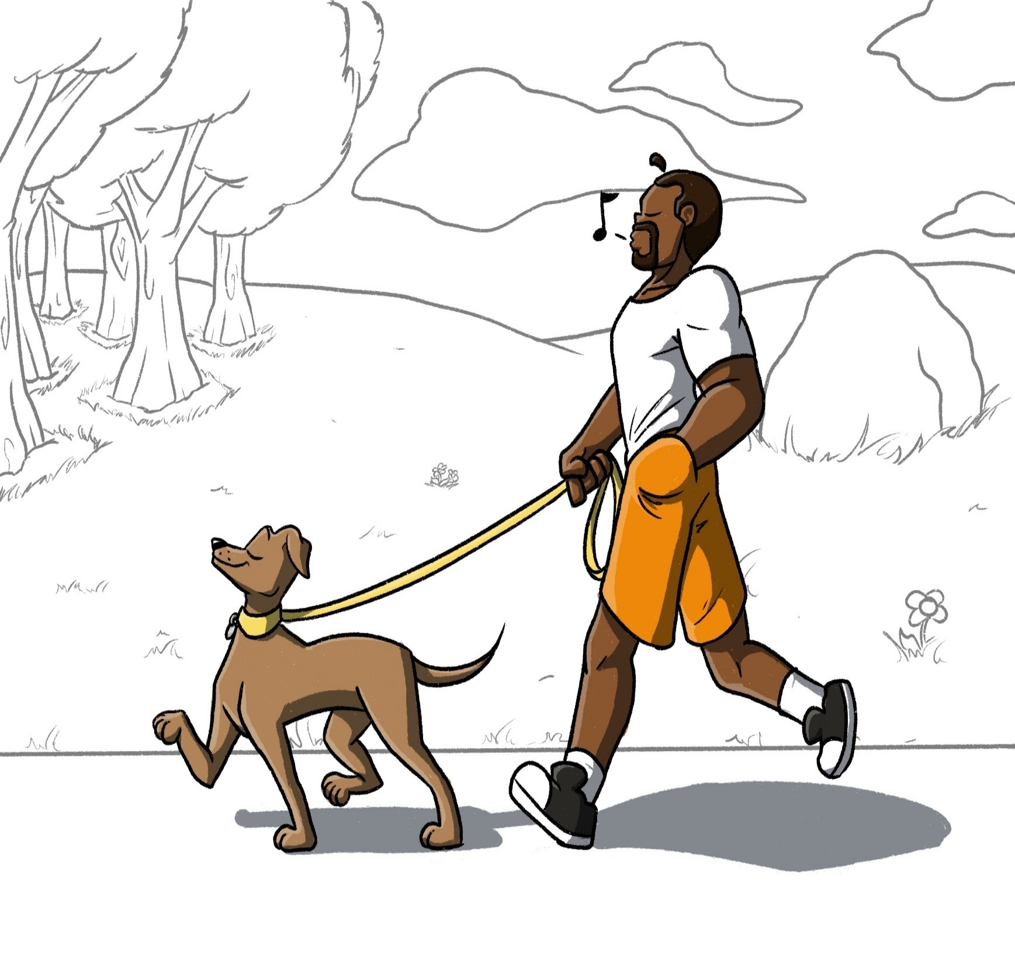

I love my dog and we love being together every day.
One day, while out walking my dog…
We passed some fresh dog POOP.

My dog decided to roll in the
poop and cover herself!
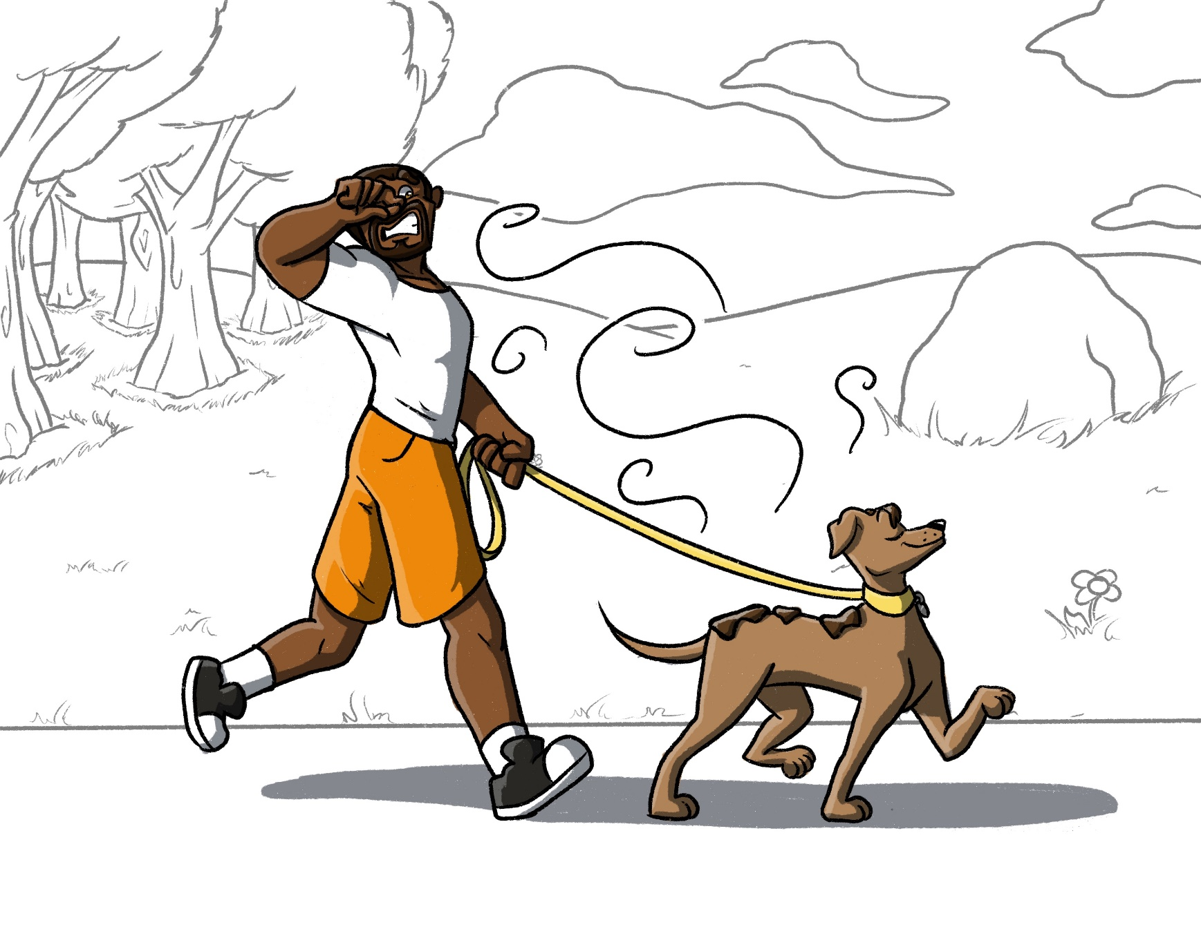
She was so proud of how she smelled.
I thought she smelled HORRIBLE!

Now what do I do?
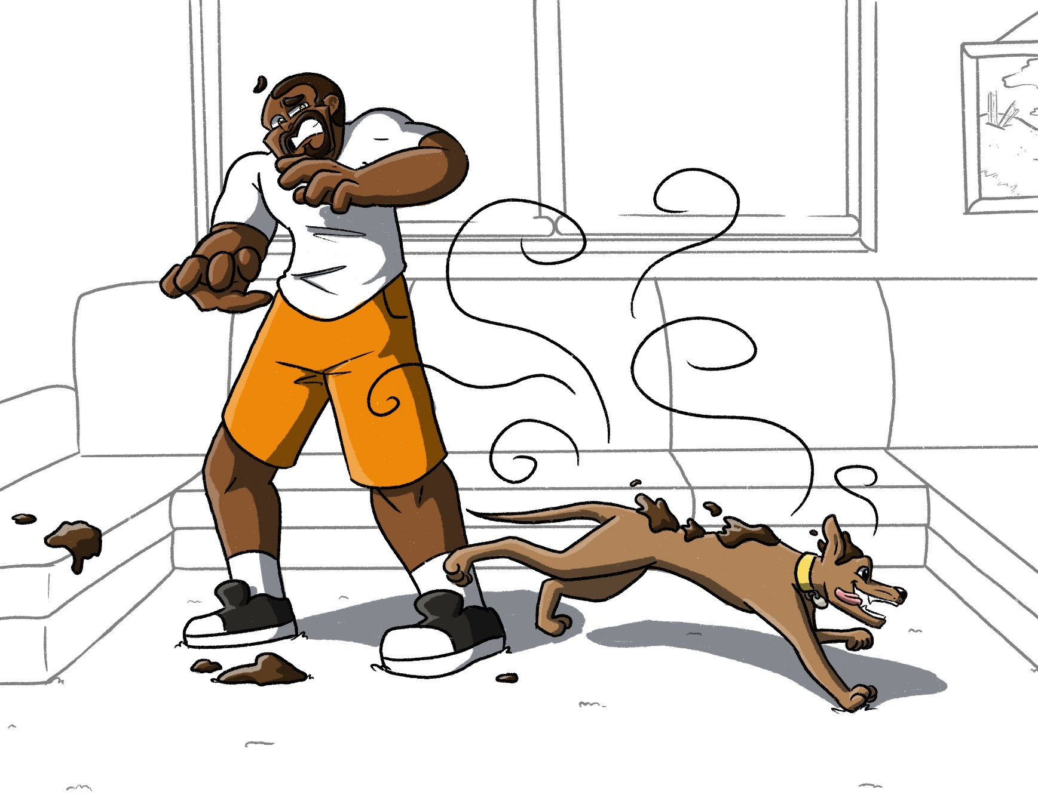

If I let her into the house covered in poop, it would get all over everything.

My house would be gross and STINK!

It would break my heart to
leave my dog outside at
night in the dark,
but I couldn’t let her in either.
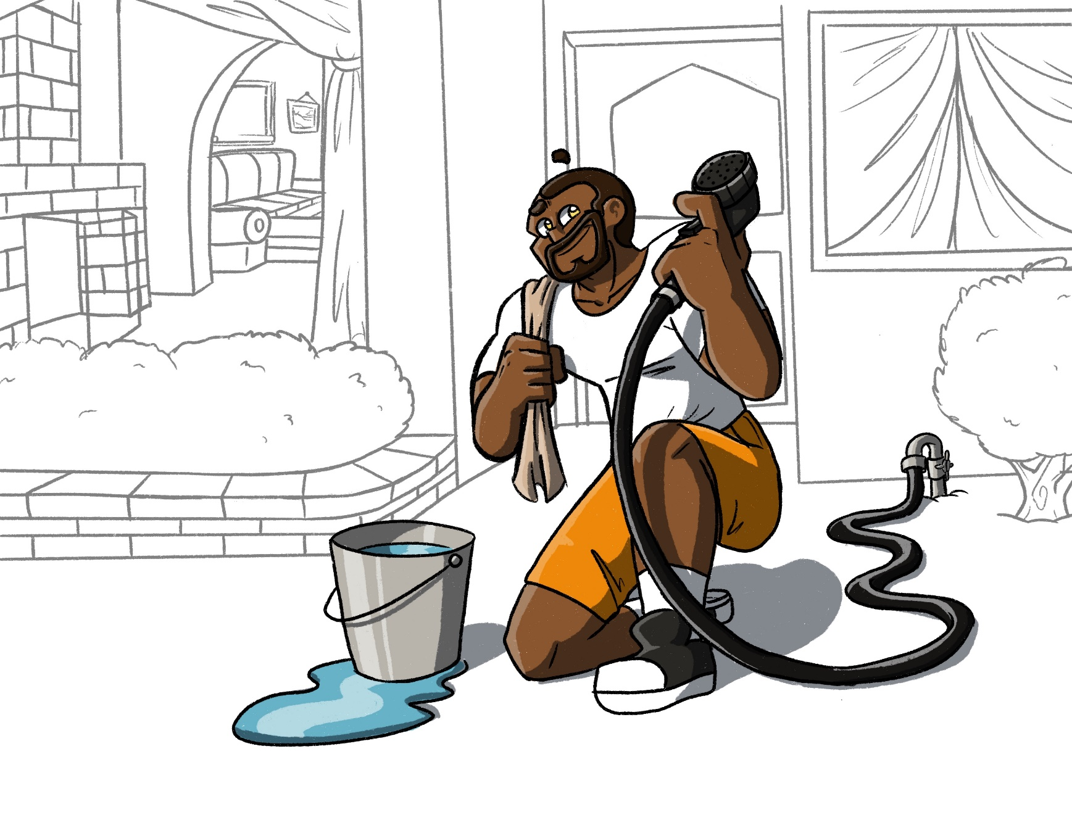
I could wash her!
IDEA!
I knew when I washed her,
I would get poop on me.

But I loved my dog,
and she was worth it.
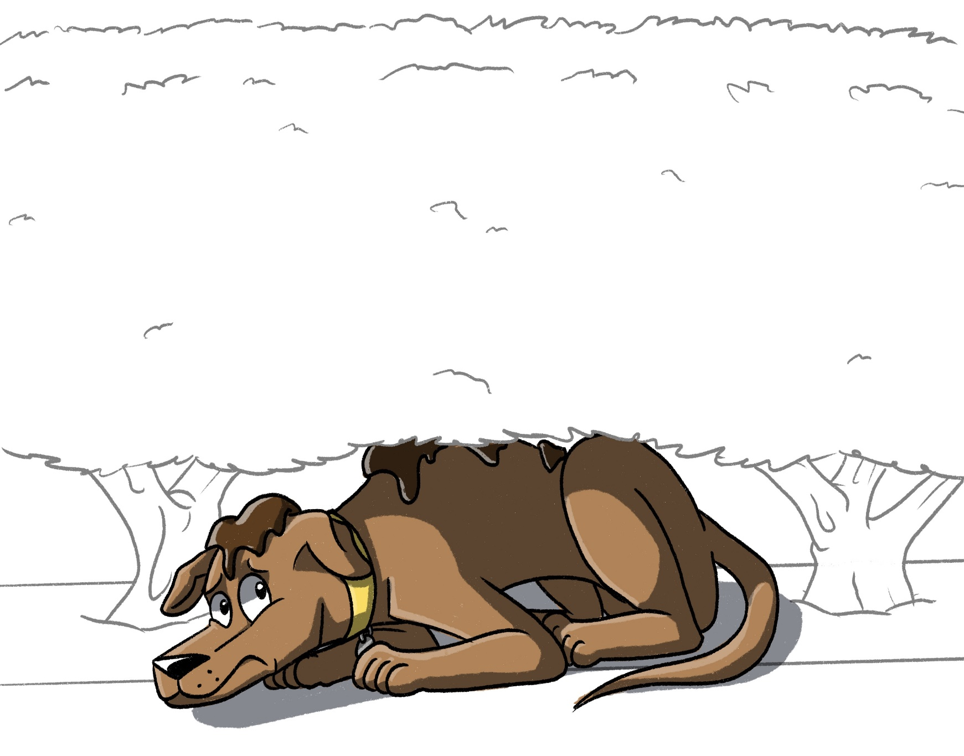
At first, she hid under the bushes, not wanting to be cleaned.

She was dirty,
but she liked her smell.
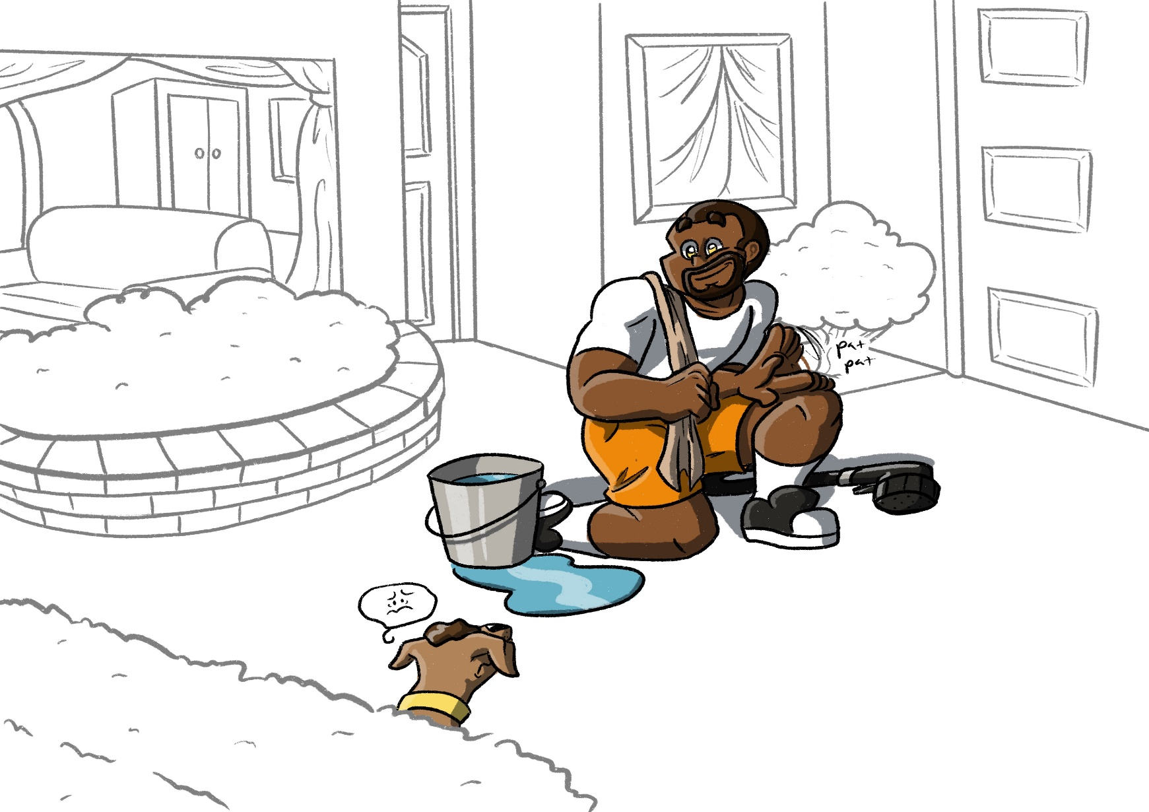
EWWWW!

I waited for my dog to come out refusing to give up. She can’t wash herself. She finally came out. At first, she didn’t like it, neither did I. I got wet and poop on me while washing her.
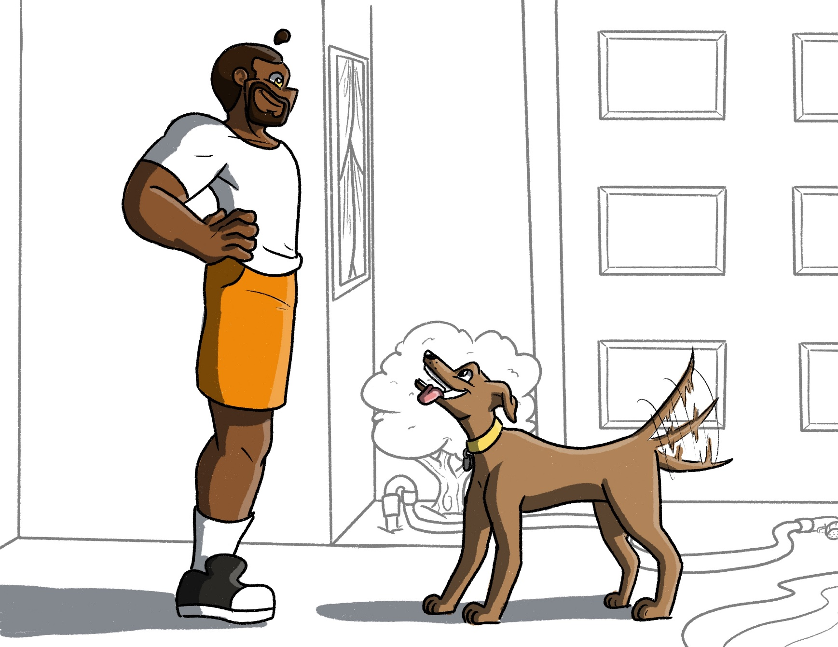
When we were finished, we were both happy and CLEAN! I didn’t want to leave my dog outside but couldn’t let her into the house until she was clean.
I loved my dog so much.
I came to her to wash her even though I would get wet and dirty too.

HOME!
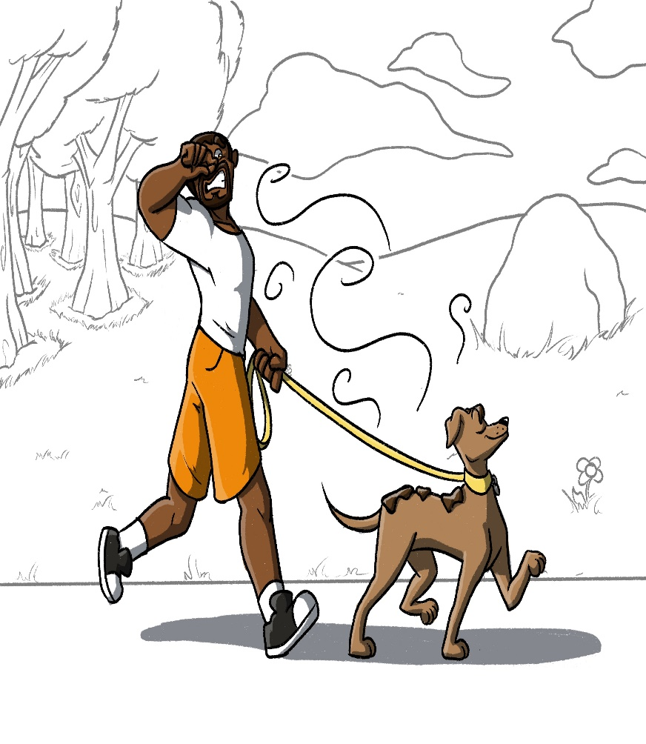

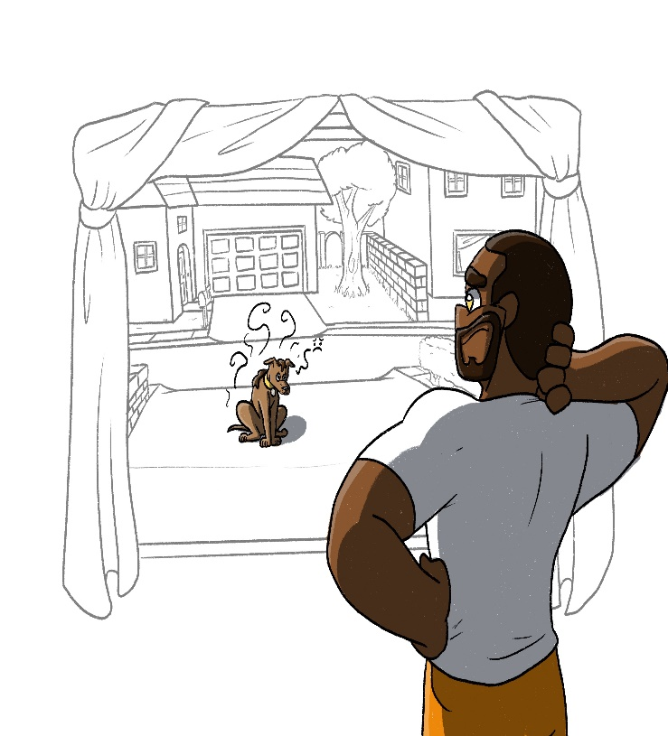

SOOO...

How does this explain about going to heaven?

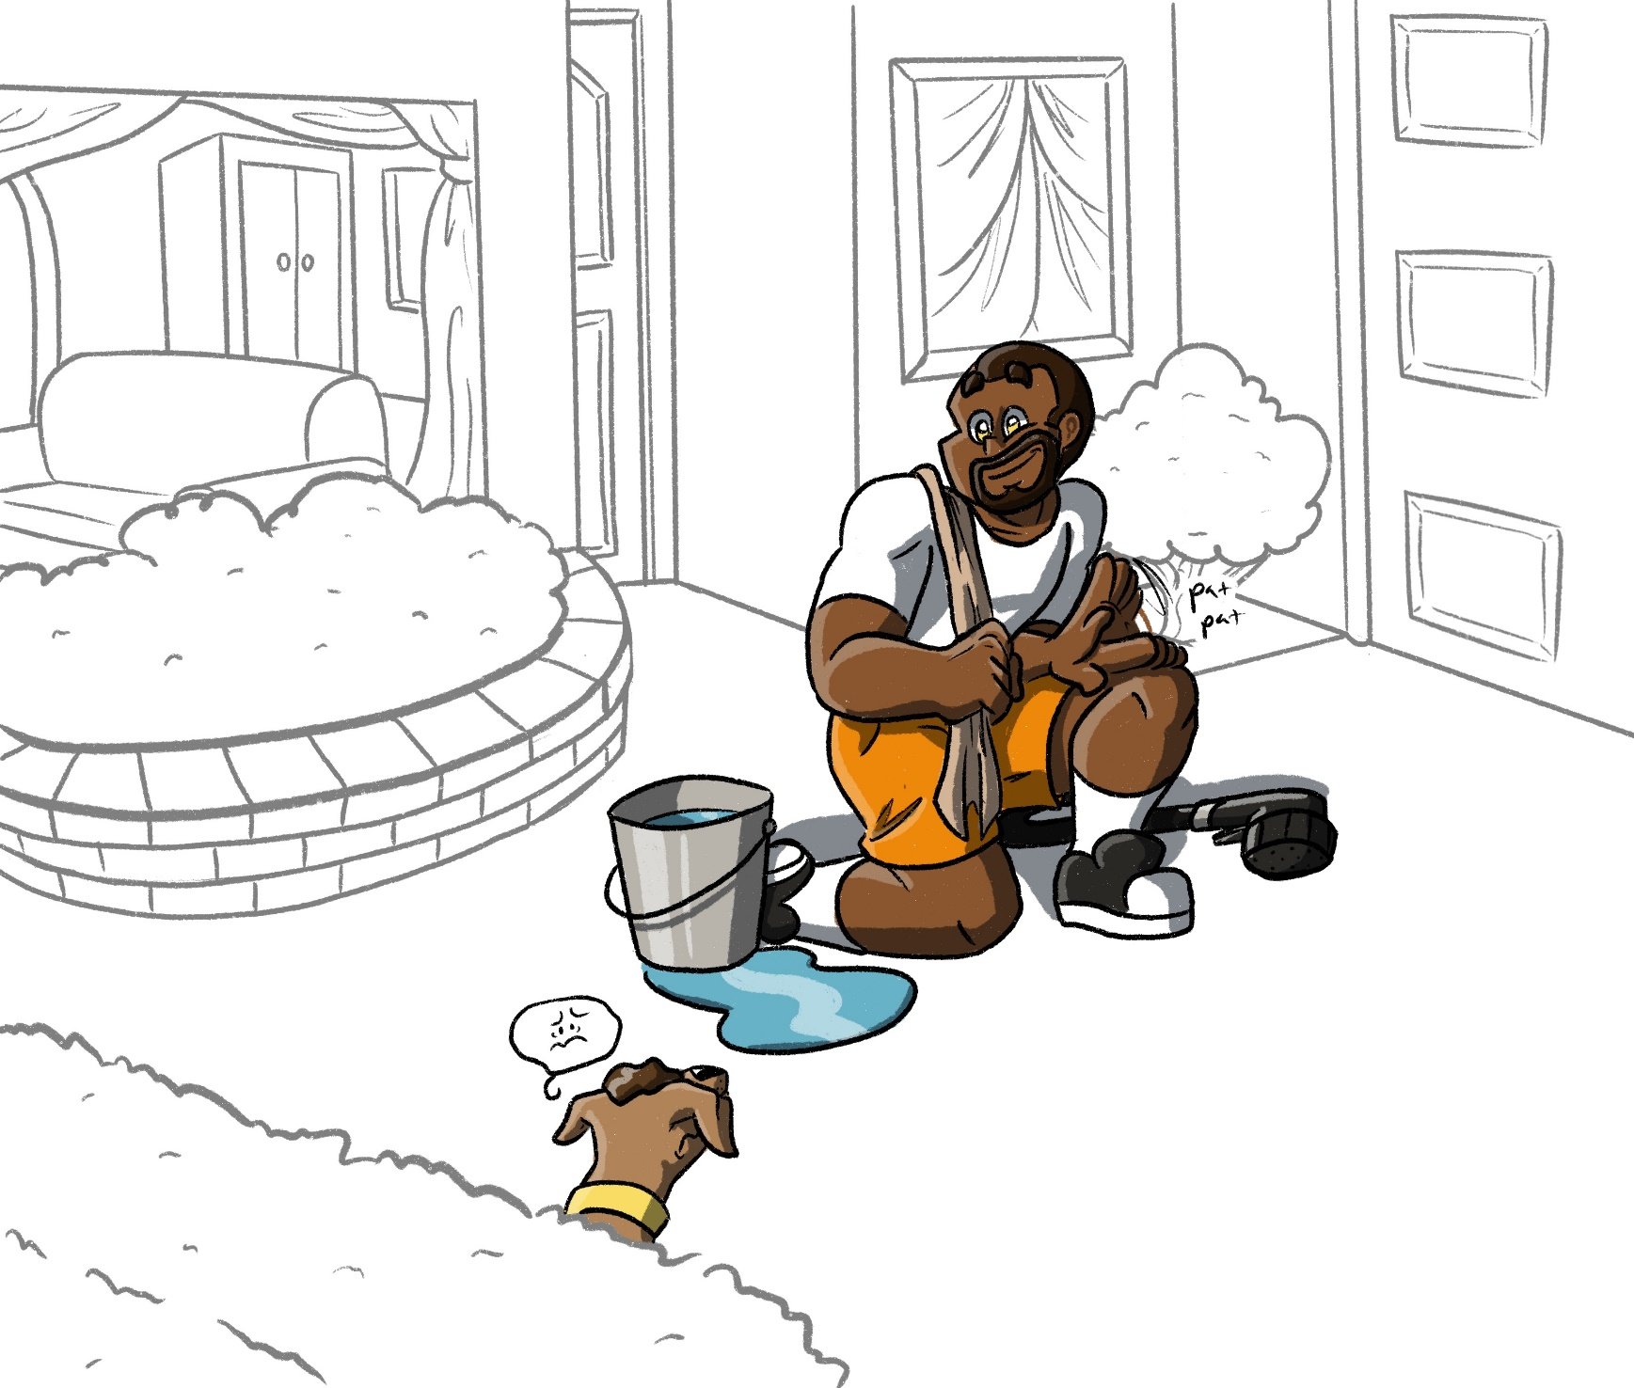

God and Us
God loves us and loves being together with us, every day. In the world… we pass POOP (sin) while walking with God. We often love our sin and enjoy it. We like doing things like lying, stealing, not helping, and gossiping. Often, we are proud of our sins. To God, we smell HORRIBLE!
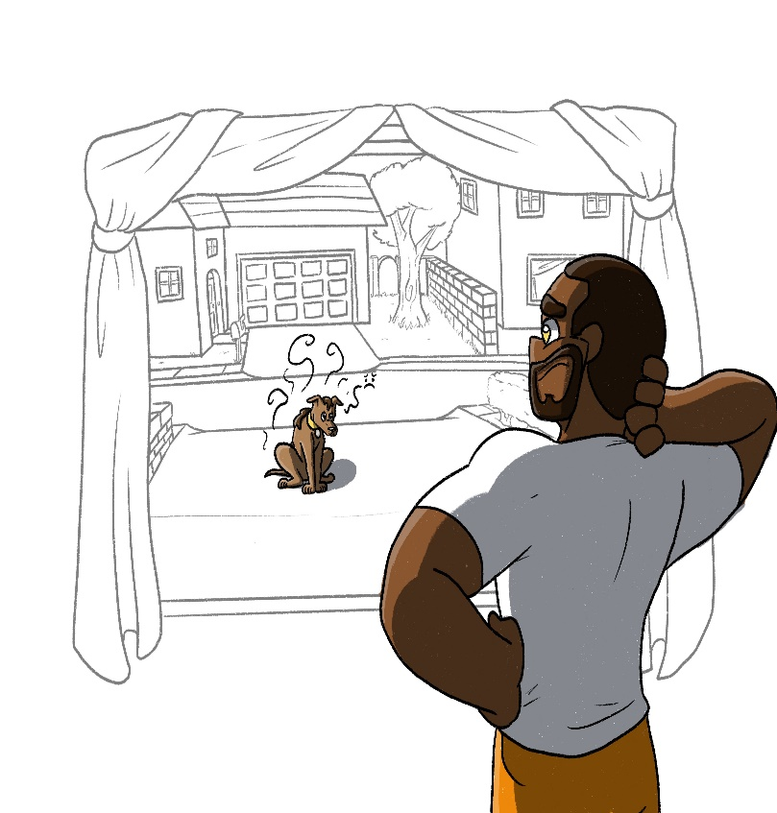
If God let us into heaven, our sins will make God’s home dirty and stink. Yet, it breaks God’s heart to leave us outside at night in the dark (hell).

What should God do? God can’t let us into heaven.
full of sin but doesn’t want us to go to hell.
God saved us through His mercy. How? By washing away our sins.

Titus 3:5

Jesus came to wash all our sins. He had to suffer to do this.
At first, we often hide. We like sinning and how it makes us look (smell), but we don’t want to show our sins and how dirty we are to God.
While we are dirty and smell bad, God sent His son, Jesus. God loves us and we are worth it.

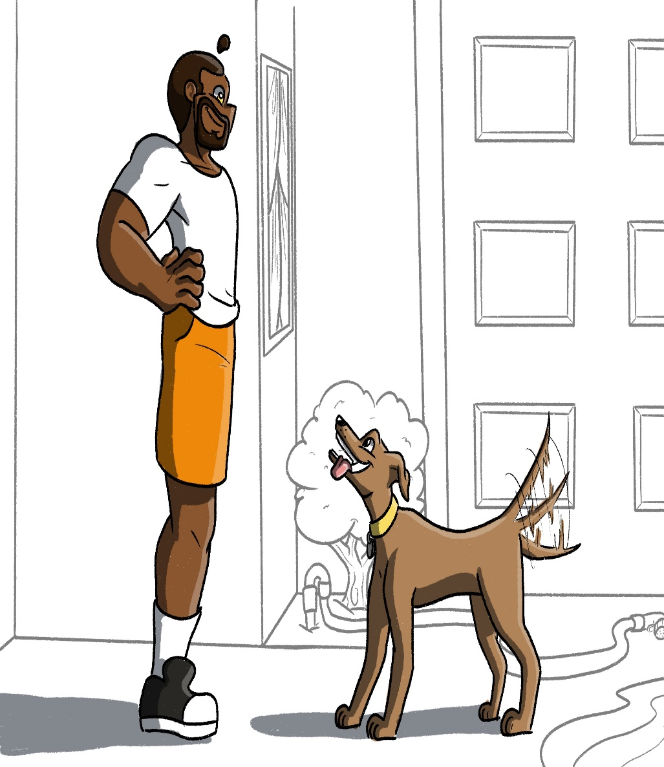
Jesus came and took our sins (poop) on himself even though he would suffer. Jesus had to accept being covered with our sin.

Why? So, we could be clean.

By believing in Jesus, we are free from our sins. Now we are happy and clean ready to enter heaven.
Because of Christ!

God loved the world (people) so much that He gave His only Son (Jesus). If you believe in Him, you will not go to hell, but live in heaven forever.
John 3:16

